**HARSHTON JUNIOR SCHOOL-MBALE**

**HOLIDAY PACKAGE TERM I-2023 TOP CLASS READING**

**Name: ……………………………………………………**

1. Copy the same sounds.

|  |  |  |  |  |  |  |  |  |  |
| --- | --- | --- | --- | --- | --- | --- | --- | --- | --- |
| c | a | t | m | n | f | h | b | g | p |
|  |  |  |  |  |  |  |  |  |  |

1. Sound and draw.

|  |  |  |  |  |
| --- | --- | --- | --- | --- |
| f | a | m | t | e |
|  |  |  |  |  |

1. Circle the old man out.

|  |  |  |  |
| --- | --- | --- | --- |
| a | a | a | d |
| e | c | c | c |
| t | t | f | t |
| s | z | s | s |
| m | n | n | n |

1. Blend and form words.

ba-g = bag

ca-t = ………………..

ma-t = ………………..

fa-n = ………………..

ya-m = ………………..

pa-n = ………………..

1. Name pictures.

|  |  |  |  |  |
| --- | --- | --- | --- | --- |
|  |  |  |  |  |
|  |  |  |  |  |
| cup | hat | ball | box | pot |

1. Fill in the missing vowel letters.

|  |  |  |  |  |
| --- | --- | --- | --- | --- |
| a | e | i | o | u |
| a | _____ | _____ | o | u |
| _____ | e | i | _____ | u |
| a | e | i | o | _____ |

1. Match sound to picture.

c

m

t

e

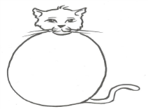h

s

1. Read and draw.

|  |  |  |  |  |  |
| --- | --- | --- | --- | --- | --- |
|  |  |  |  |  |  |
| flower | pencil | book | cat | boy | car |

1. Write the sounds correctly.

|  |  |  |  |  |  |
| --- | --- | --- | --- | --- | --- |
| a | b | c | d | e | f |
|  |  |  |  |  |  |

1. Read the syllables.

ba ca fa ha ma

**LEARNING AREA ONE AND THREE**

1. 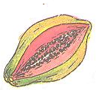Circle the different picture.

|  |  |  |
| --- | --- | --- |
|  |  |  |
| Tomato | D:\Esteem Jr Sch Documents\pictures\CASSAVA 2.jpg |  |
| D:\Esteem Jr Sch Documents\pictures\CASSAVA 2.jpg |  |  |
|  |  |  |
|  |  |  |

1. 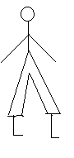Name these pictures.

_______________

 _______________

_______________

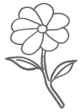______________ _______________

**(sun, moon, flower, star, man)**

1. Read, match and draw.

leg____________

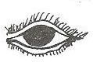

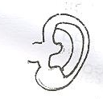 nose____________

tongue_________

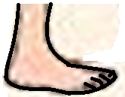

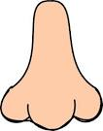 head___________

eye___________

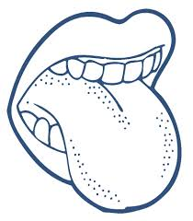

ear___________

1. Tick the same word.

|  |  |  |
| --- | --- | --- |
| toothbrush | basin | toothbrush |
| towel | towel | knee |
| cup | comb | comb |
| soap | soap | skirt |
| water | wall | water |

1. Read and draw.

|  |  |
| --- | --- |
|  |  |
| baby | sister |
|  |  |
| father | brother |
|  |
| mother |

1. 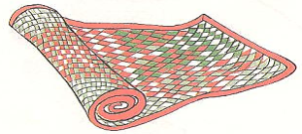Match.

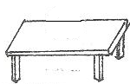ball

chair



book



table

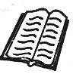

mat

1. Fill in the missing letters.

skirt dress short

s__irt dr__ss sh___rt

shoes

s___oes

**LEARNING AREA TWO**

1. Read and draw important places.

|  |  |
| --- | --- |
| garden |  |
| school |  |
| mosque |  |
| police station |  |
| church |  |
| hospital |  |

1. 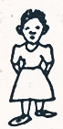Match people at school to words.

nurse

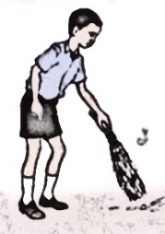

cook

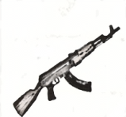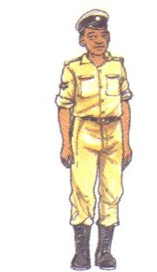

metron

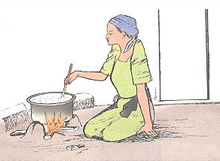

cleaner



police

1. Match dangerous things to words.

stone

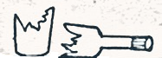 fire

 pin

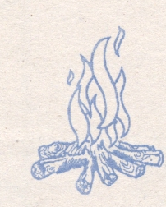 broken bottle

snake

1. 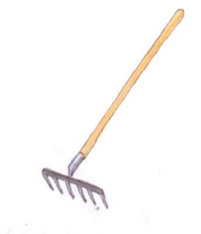Copy and draw the same.

|  |  |  |  |
| --- | --- | --- | --- |
|  | panga |  | rake |
|  |  |  |  |
|  | rag |  | broom |
|  |  |  |  |

1. Read and draw animals.

|  |  |
| --- | --- |
| cow |  |
| dog |  |
| cat |  |
| rabbit |  |
| goat |  |

1. Circle the odd one out.





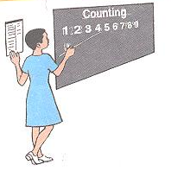

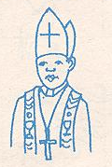

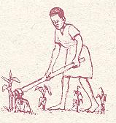

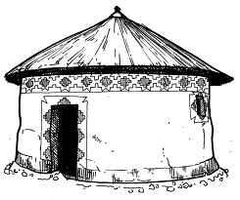

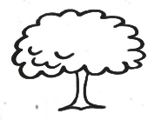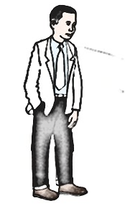

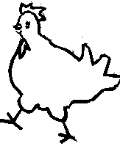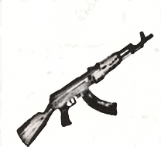

**ENGLISH**

1. Circle the same words.

sun sun egg

mat leg mat

gun hut hut

rat rat in

hen man hen

1. Read and match.

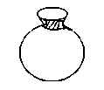egg

sun

mat

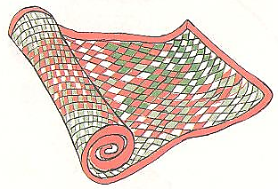tin

pot

1. Copy and write the same.

|  |  |  |  |  |
| --- | --- | --- | --- | --- |
| a | b | c | d | e |
|  |  |  |  |  |
| f | g | h | i | j |
|  |  |  |  |  |
| k | l | m | n | o |
|  |  |  |  |  |
| p | q | r | s | t |
|  |  |  |  |  |
| u | v | w | x | y |
|  |  |  |  |  |
| z |
|  |

1. Name these pictures.

|  |  |
| --- | --- |
|  |  |
|  |  |
|  |  |
|  |  |
|  |  |
|  |  |

**( egg, tin, box, tree, car, girl )**

1. Read and draw.

|  |  |
| --- | --- |
|  |  |
| tin | apple |
|  |  |
| boy | cat |
|  |  |
| pot | sun |

1. Draw the picture friends.

|  |  |  |  |
| --- | --- | --- | --- |
| a | | b | |
| D:\Esteem Jr Sch Documents\pictures\apple.jpg |  |  |  |
| c | | d | |
|  |  |  |  |
| e | |
|  |  |

**LEARNING AREA FOUR**



1. **Write numbers l – 20**

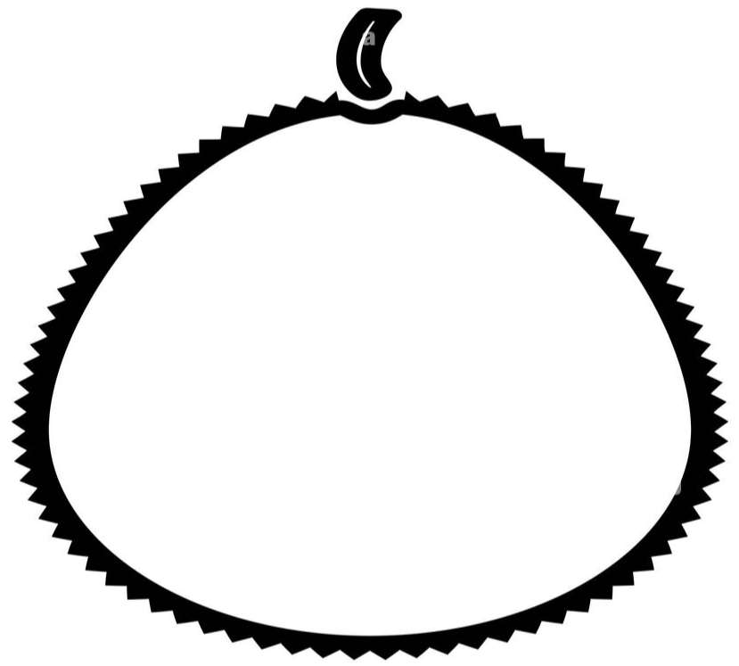

1

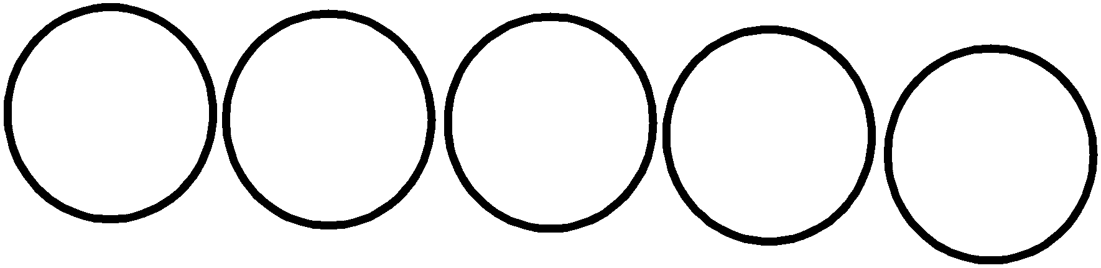

1. **Match and write**

star rectangle

circle

triangle

square

rectangle

1. **Make new numbers using cards**



I I

I 2

I 9

I 7

2 3

2 8

|  |  |
| --- | --- |
| =  = | I I |
| = |  |
| = |  |
| = |  |
| = |  |

**Draw balls for numbers**



7 =

9 =

6 =

8 =

10 =

2 =

**Fill in the missing numbers.**

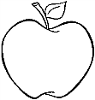

*l 3 5*

*l*

*6 7 l0*

*ll l3*

**Count and write in words**

**( five, four, one )**

**Count and circle**

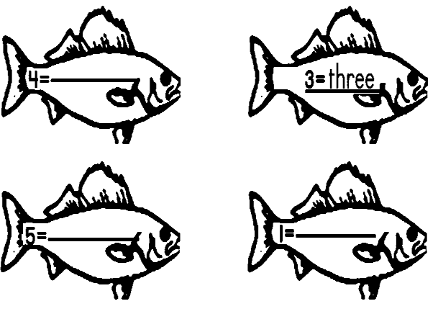

= 3 7 6

= 9 2 5

= 10 1 8

**Write in words**

= 2 7 9

one three four five

**( one, three, four, five )**

**Shade for the number**

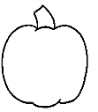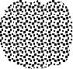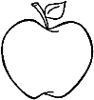

=

9 =

3 =

6 =

5 =

**Take me to home l0 – 20**

